Regulatory Committee
Meeting to be held on 15th September 2021

Part I

Electoral Division affected:
South Ribble West

Wildlife and Countryside Act 1981
Definitive Map Modification Order Investigation
Bridleway between Liverpool Road and Northern Avenue, Much Hoole
(Annex ‘A’ refers)

Contact for further information quoting reference 804-627:
Simon Moore, 01772 531280, Paralegal Officer, County Secretary and Solicitors Group, Simon.Moore@lancashire.gov.uk
Jayne Elliott, 01772 537663, Public Rights of Way Definitive Map Officer, Planning and Environment Group, jayne.elliott@lancashire.gov.uk

Executive Summary

Application for the upgrading of existing public footpaths on the Definitive Map and Statement of Public Rights of Way from Liverpool Road to the junction with Northern Avenue which continues through to the junction with Smithy Lane, Much Hoole.

Recommendation

That the application for to upgrade 7-8-FP 30 and part of 7-8-FP 29 to

bridleway on the Definitive Map and Statement of Public Rights of Way be accepted save for rights for restricted byway and section D to E instead be an addition of restricted byway on a different line instead of an upgrade of part of 7-8-FP30.

That an Order be made pursuant to Section 53 (2)(b) in consequence of

events specified in Section 53(3)(b) and/or Sections 53(3)(c)(i) and 53(3)(c)(ii) of the Wildlife and Countryside Act 1981 to add to the Definitive Map and Statement of Public Rights of Way a restricted byway along the route marked red as shown on Committee Plan between points D and E and marked "historical route" on the Committee plan and to upgrade to restricted byway parts of 7-8-FP 30 and 7-8-FP 29 shown between points A and D also E and H on the Committee Plan.

That being satisfied that the higher test for confirmation can be met in respect

of the addition and the test for confirmation be met in respect of the upgraded sections, the Order be promoted to confirmation.

Background

An application under Schedule 14 of the Wildlife and Countryside Act 1981 has been received for the upgrading of the public footpath shown on the Definitive Map and Statement from Liverpool Road to the junction with Northern Avenue which continues through to the junction with Smithy Lane, Much Hoole as a footpath on the Definitive Map and Statement.

The county council is required by law to investigate the evidence and make a decision based on that evidence as to whether a public right of way exists, and if so its status. Section 53(3)(b) and (c) of the Wildlife and Countryside Act 1981 set out the tests that need to be met when reaching a decision; also current Case Law needs to be applied.

An order for upgrading or downgrading a way shown on the Definitive Map and Statement will only be made if the evidence shows that:

- "it ought to be there shown as a highway of a different description"

An order for adding a way to or upgrading a way shown on the Definitive Map and Statement will be made if the evidence shows that:

- “the expiration… of any period such that the enjoyment by the public…raises a presumption that the way has been dedicated as a public path or restricted byway”

When considering evidence, if it is shown that a highway existed then highway rights continue to exist (“once a highway, always a highway”) even if a route has since become disused or obstructed unless a legal order stopping up or diverting the rights has been made. Section 53 of the Wildlife and Countryside Act 1981 makes it clear that considerations such as suitability, the security of properties and the wishes of adjacent landowners cannot be considered. The Planning Inspectorate’s website also gives guidance about the interpretation of evidence.

The county council’s decision will be based on the interpretation of the evidence discovered by officers and documents and other evidence supplied by the applicant, landowners, consultees and other interested parties produced to the County Council before the date of the decision. Each piece of evidence will be tested and the evidence overall weighed on the balance of probabilities. It is possible that the council’s decision may be different from the status given in any original application. The decision may be that the routes have public rights as a footpath, bridleway, restricted byway or byway open to all traffic, or that no such right of way exists. The decision may also be that the routes to be added or deleted vary in length or location from those that were originally considered.

Consultations

South Ribble Borough Council

South Ribble Borough Council provided no response to our consultation.

Much Hoole Parish Council

Much Hoole Parish Council provided no response to our consultation.

Applicant/Landowners/Supporters/Objectors

The evidence submitted by the applicant/landowners/supporters/objectors and observations on those comments are included in Advice – Head of Service – Legal and Democratic Services Observations.

Advice

Head of Service – Planning and Environment

Points annotated on the attached Committee plan.

Point | Grid Reference (SD) | Description
A | 4660 2266 | Open junction of 7-8-FP30 with Liverpool Road (A59)
B | 4667 2267 | Point on application route adjacent to south east corner of rear boundary fence of 3 Brooklands
C | 4668 2268 | Metal kissing gate
D | 4683 2269 | Point on application route at which the currently accessible route diverges from 7-8-FP30 and 'historical route' marked by a dashed coloured line on the Committee plan
E | 4684 2273 | Junction of 7-8-FP30 and 'historical route' with the access road to Greenfield
F | 4686 2273 | Field gate across application route
G | 4687 2274 | Junction of 7-8-FP30 and 7-8-FP29 (the application route) with 7-8-FP27 and 7-8-FP28
H | 4699 2274 | Junction of 7-8-FP29 with Northern Avenue
D-X | 4683 2269 to 4685 2270 | Route currently used by the public in lieu of D-E

Description of Route

A site inspection was carried out in June 2021.

n.b. Reference to public rights of way shown on the Definitive Map and Statement are generally given in the form '7-8-FP29' or 'Much Hoole Footpath 29' but are referenced below in the abbreviated form FP29 for brevity since all those referred to are in Much Hoole.

The application submitted to the county council specifically referred to the application route being the routes recorded as FPs 30 and 29 and no user evidence was submitted in support.

The application route commences at a point on the eastern side of Liverpool Road, running to the north of and adjacent to a watercourse which is to the north of 211 Liverpool Road and which flows west under the carriageway of Liverpool Road.

At point A the route is signposted as a public footpath in accordance with its recorded status. Attached to the signpost is a circular sign providing additional information and a map of the route and other routes connecting to it which was designed and erected by Much Hoole Parish Council as part of a parish initiative a number of years ago. Also attached to the signpost is a typed notice notifying users that part of the path has eroded and that a parish council repair team would be on site shortly to fix it.

From point A the route follows a compact stone surfaced path bounded to the north by substantial wooden fencing separating the route from the residential properties on Brooklawns. To the south there is a sharp vegetated drop down to the watercourse which runs parallel to the route.

At point B the fencing bounding 3 Brooklawns curves round to continue north away from the application route and between point B and point C the application route continues adjacent to the watercourse and bounded by a hedge to the north.

At point C the route is crossed by a metal kissing gate where there is a further notice warning of damage to the surface of the path and evidence of the surfaced path being washed away into the watercourse. Immediately beyond point C the watercourse is culverted to the south of the application route.

Beyond point C the application route continues in an easterly direction along a wide strip of land (approximately 10 metres wide) mostly overgrown with a narrow (1-1.5 metre wide) stone surfaced path along the middle through to point D.

At point D the recorded route of FP30 turns north to continue along the boundary of the property known as Greenfield to exit onto the access road leading to Greenfield at point E.

On site the application route is not visible or accessible. Instead the land crossed by the application route appears to have been fenced off just north of point D some time ago and is now very overgrown. A stone surfaced path continues from point D in an easterly direction to point X on the Committee plan where it meets the recorded route of FP27 and the only accessible link then turns north along FP 27 to pass through a further metal kissing gate and to re-join the application route at point G.

Between point D and point E the recorded route of FP 30 is not accessible and neither is the route shown on the Committee plan labelled as the 'Historical route' which runs parallel to FP 30 but on the west side of the boundary of Greenfield from points D to E.

From point E the continuation of the application route is accessible and forms part of the access road leading directly to Greenfield. At point F the route is crossed by a metal field gate which was open when the route was inspected.

At point G the application route meets the footpaths recorded as FP 27 and 28 and then continues east as a wide compacted earth and stone access road recorded as FP 29.

Approximately 95 metres east of point G the application route provides access on the south side to a recently constructed housing development known as Turnpike Close and from this point through to point H the route has a tarmac surface.

At point H the route joins the western end of Northern Avenue which is recorded as a publicly maintainable vehicular highway. A public footpath signpost is located at point H pointing west along the application route and a further circular information notice is attached to the signpost similar to the one located at point A.

The total length of the route A-B-C-D-E-F-G-H is approximately 450 metres.

Map and Documentary Evidence

A variety of maps, plans and other documents were examined to discover when the route came into being, and to try to determine what its status may be.

Document Title | Date | Brief Description of Document & Nature of Evidence
Yates’ Map  of Lancashire | 1786 | Small scale commercial map. Such maps were on sale to the public and hence to be of use to their customers the routes shown had to be available for the public to use. However, they were privately produced without a known system of consultation or checking. Limitations of scale also limited the routes that could be shown.
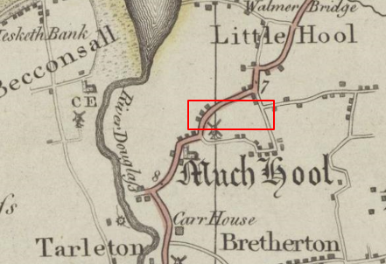
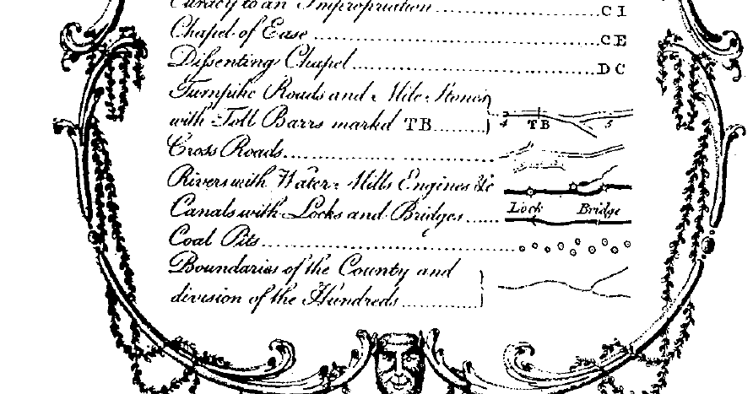
Observations |  | The application route is not shown.
Investigating Officer's Comments |  | The application route probably did not exist at the time or if it did exist, was not considered to be a substantial public vehicular route by Yates. If it did exist it would have been very unlikely for a route considered to be a footpath or bridleway to be shown on such a small-scale map.
Cary's Map of Lancashire | 1787 | John Cary was described as 'the most representative, able and prolific of English cartographers'. He was as busy a publisher as he was a cartographer and engraver, and until his death in 1835 published a constant flow of atlases, maps, road maps, canal plans, globes and geological surveys. He set new high standards of engraving and map design and in 1787 he published a 'New and Correct English Atlas' containing 46 maps which was re-issued ten times until 1831.  In 1794 the Postmaster General commissioned Cary to survey the main roads of Great Britain and his information on roads may be viewed with above average confidence.
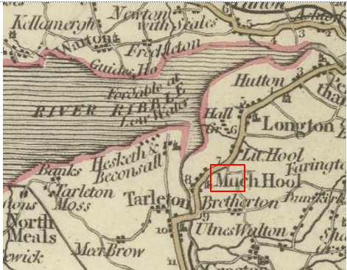
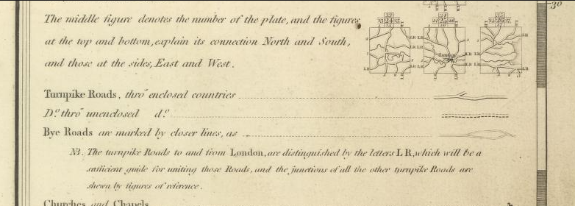
Observations |  | The application route is not shown.
Investigating Officer's Comments |  | The application route probably did not exist at the time or if it did exist, was not considered to be a substantial public vehicular route. If it did exist it would have been very unlikely for a route considered to be a footpath or bridleway to be shown on such a small-scale map.
Greenwood’s Map of Lancashire | 1818 | Small scale commercial map. In contrast to other map makers of the era Greenwood stated in the legend that this map showed private as well as public roads and the two were not differentiated between within the key panel.
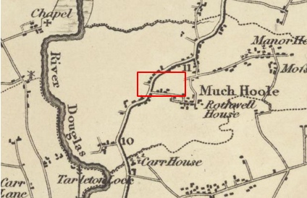
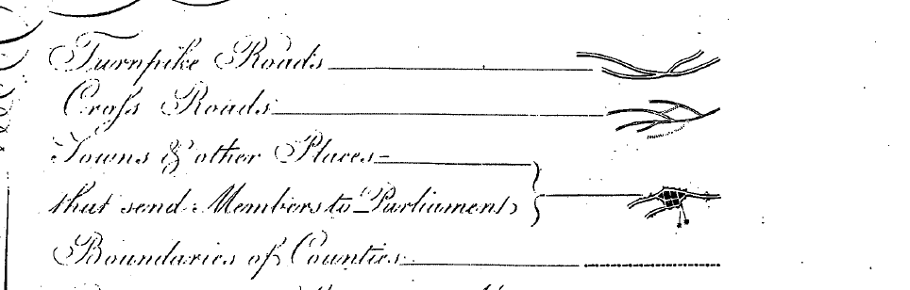
Observations |  | The application route is not shown on the map although a short stub possibly indicating the start of a route can be seen extending west from Smithy Lane consistent with the eastern end of Northern Avenue.
Investigating Officer's Comments |  | The application route probably did not exist as a through route at the time or if it did exist, was not considered to be a substantial public vehicular route by Greenwood. If it did exist it would have been very unlikely for a route considered to be a footpath or bridleway to be shown on such a small-scale map.
Hennet's Map of Lancashire | 1830 | Small scale commercial map. In 1830 Henry Teesdale of London published George Hennet's Map of Lancashire surveyed in 1828-1829 at a scale of 71/2 inches to 1 mile. Hennet's finer hachuring was no more successful than Greenwood's in portraying Lancashire's hills and valleys but his mapping of the county's communications network was generally considered to be the clearest and most helpful that had yet been achieved.
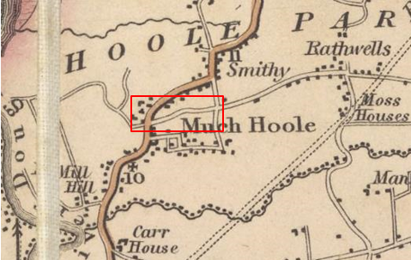
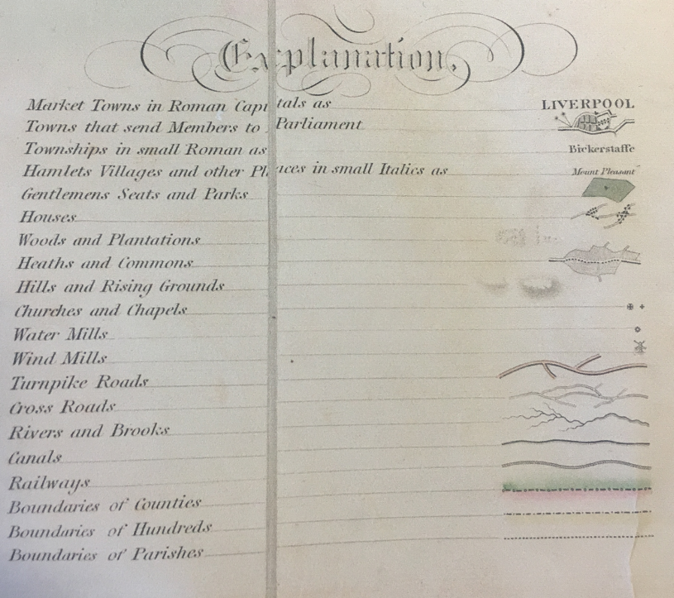
Observations |  | The full length of a route similar to the application route is shown as a cross road consistent with how other routes now recorded as public vehicular routes are shown. However, although linking the same points the alignment is different.
Investigating Officer's Comments |  | It is not fully known what is meant by the term 'cross road'. As the only other category of 'road' shown on the map are turnpike roads, it is possible that a cross road was regarded as either a public minor cart road or a bridleway (as suggested by the judge in Hollins v Oldham).  Hollins v Oldham Manchester High Court (1995) [C94/0205] Judge Howarth examined various maps from 1777-1830 including Greenwoods, Bryants and Burdetts. Maps of this type, which showed cross roads and turnpikes, were maps for the benefit of wealthy people and were very expensive. There was “no point showing a road to a purchaser if he did not have the right to use it.”  It is unlikely that a map of this scale would show footpaths suggesting that a route existed as a substantial through route which was considered to be more than a public footpath at that time. The pronounced 90 degree bend is not shown on the route but this is considered to be the limitations of small scale mapping at this time and Hennet's style of mapping – other examples can be seen on the same extract in the depiction of the junction of Brook Lane with Liverpool Road and the square at Lunds Lane/Town Lane.
Canal and Railway Acts |  | Canals and railways were the vital infrastructure for a modernising economy and hence, like motorways and high-speed rail links today, legislation enabled these to be built by compulsion where agreement couldn't be reached. It was important to get the details right by making provision for any public rights of way to avoid objections but not to provide expensive crossings unless they really were public rights of way. This information is also often available for proposed canals and railways which were never built.
Observations |  | The land crossed by the application route was not affected by any existing or proposed canals.
Investigating Officer's Comments |  | No inference can be drawn with regards to the existence of public rights.
Tithe Map and Tithe Award or Apportionment | 1841 | Maps and other documents were produced under the Tithe Commutation Act of 1836 to record land capable of producing a crop and what each landowner should pay in lieu of tithes to the church. The maps are usually detailed large scale maps of a parish and while they were not produced specifically to show roads or public rights of way, the maps often show roads quite accurately and can provide useful supporting evidence (in conjunction with the written tithe award) and additional information from which the status of ways may be inferred.
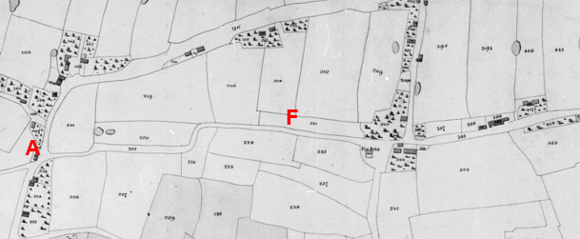
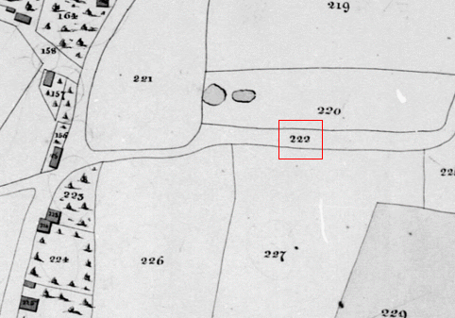
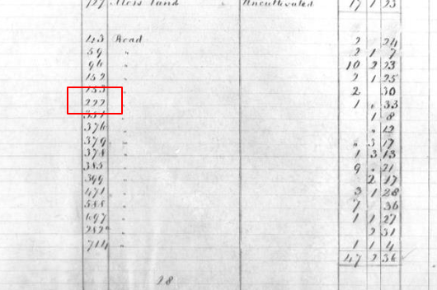
Observations |  | A route consistent with the application route or approximating to the full length of the application route starting on Liverpool Road and then continuing through to the junction with Smithy Lane appears to be shown as a substantial bounded through route and is numbered as plot 222 and is listed at the end of the Tithe Award as a road.  The list comprises 17 routes which are labelled at the end of the Award as 'Road'. Looking more closely at the 17 routes listed, 12 of those routes are now recorded as vehicular highways for all or most, or in 1 case some, of their length, 2 routes (including the application route) are subject to applications to be upgraded, 1 is recorded as footpath and 2 have no recorded public status and of which there is no physical trace.
Investigating Officer's Comments |  | A route existed in 1841 which was similar to the application route, listed as 'road' and was probably considered to be part of the public highway network at that time.
Inclosure Act Award and Maps |  | Inclosure Awards are legal documents made under private acts of Parliament or general acts (post 1801) for reforming medieval farming practices, and also enabled new rights of way layouts in a parish to be made. They can provide conclusive evidence of status.
Observations |  | There is no Inclosure Award for the land crossed by the application route.
Investigating Officer's Comments |  | No inference can be drawn with regards to the existence of public rights.
6 Inch Ordnance Survey (OS) Map Sheet 68 | 1848 | The earliest Ordnance Survey 6 inch map for this area surveyed in 1844 to 1845 and published in 1848.
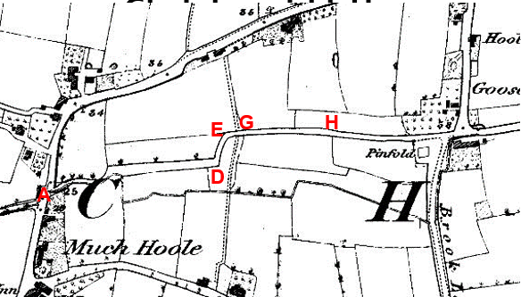
OS map extract taken from map in LCC possesion

Map extract taken from map deposited at the National Library of Scotland
Observations |  | There is a fenced through route between Liverpool Road and Smithy Lane crossed by a less significant north-south route at point G. The application route does not exactly follow this route between points D-E as the applicant relied on where the public footpath is recorded parallel but further to the east. The western end A-B is shown on this slightly later, more precise Ordnance Survey map as being narrower than on the Tithe Map and a watercourse is shown running within the south side of the enclosed strip. At its narrowest point the available width is about 17' (5 metres). There are no lines shown across the route and it was open to the highway network.
Investigating Officer's Comments |  | The application route existed in 1844-1845 consistent with how it is depicted on the Tithe Map prepared only a few years earlier. It is shown as part of a significant fenced through route crossed by a less significant north-south route at point G suggesting that it would have been capable of being used at least on horseback at that time and possibly with horse-drawn vehicles. There were no gates at the ends or along the route.
Cassini Map Old Series | 1842-1852 | The Cassini publishing company produced maps based on Ordnance Survey mapping. These maps have been enlarged and reproduced to match the modern day 1:50,000 OS Landranger Maps and are readily available to purchase.
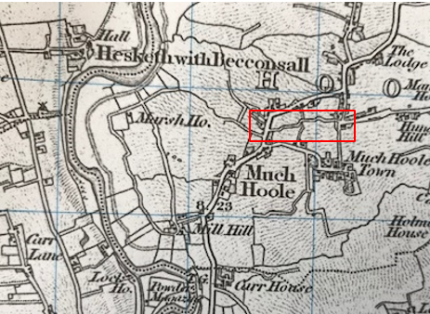
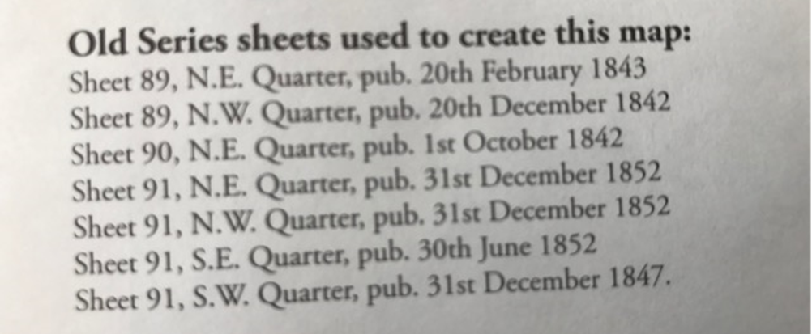
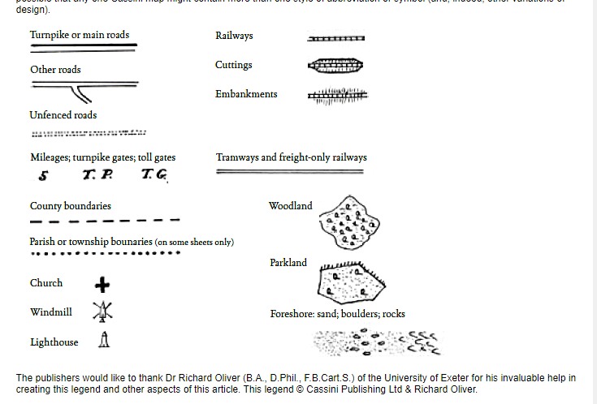
Observations |  | The full length of a route roughly consistent with the application route appears to be shown as part of a longer through route described in the map key as 'other road' connecting to public vehicular highways at both ends.
Investigating Officer's Comments |  | The original scale of the map (1 inch to the mile) means that only the more significant routes are generally shown. The purpose of the map in the late 1800s would probably have been to assist the travelling public on horseback or vehicle suggesting that the through roads shown, including the application route, had public rights for those travellers.
25 Inch OS Map  Sheet LXVIII.15 | 1893 | The earliest OS map at a scale of 25 inch to the mile. Surveyed in 1892 and published in 1893.
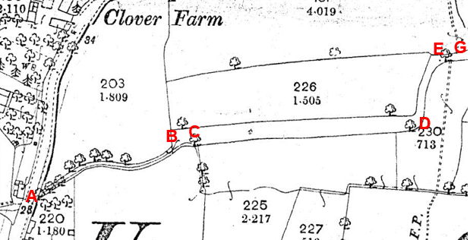
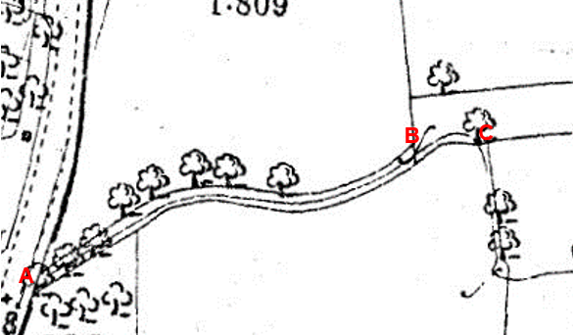
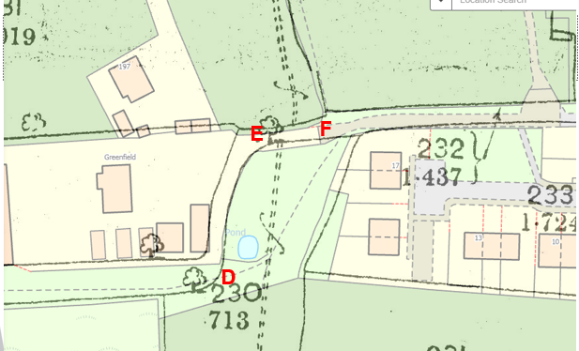
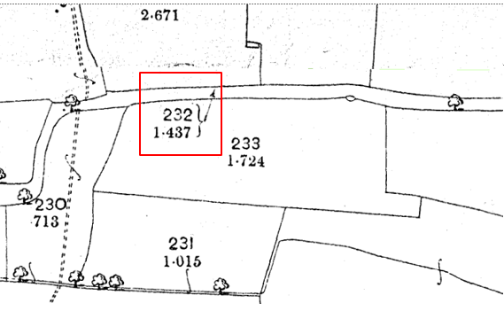
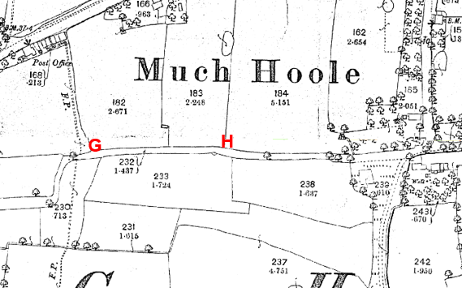
Observations |  | The First Edition 25 inch OS map provides much more detail than previous maps inspected.  A route consistent with that shown between Liverpool Road and Smithy Lane is shown on the map. The route appears to be shown with lines across it at point A and point B and is enclosed between the two points with a watercourse running within the enclosed strip. The watercourse joins the route at point C (as it still does today) from the south. The strip on the north of the stream is significantly narrower than in 1845.  From point B to point D a wide enclosed strip of land is shown consistent with how the route is still bounded today.  From point D to point E a route is shown turning north and then east fenced from adjacent fields. With the benefit of being able to view a digital overlay of the first edition 25 inch map with a modern OS base map it can be seen that the route which existed in the late 1800s – and which is most likely to be the route depicted on the Tithe Map and earlier small scale OS maps – differs from the route recorded as part of FP30 (the application route) between point D and point E and ran to the west of the existing boundary of the property known as Greenfield as marked on the Committee plan as the 'Historical route'.  The application route between point D and point E (along the property boundary) is not shown on the 1893 map.  From point E passing through points F, G and H a fenced off route is shown continuing through to the junction with Smithy Lane.  Two routes labelled on the map as footpath (F.P) are shown to cross the application route between points E and H which are on slightly different alignments from the routes now recorded as FPs 27 and 28.  The route shown is not named and there is no thickened line shown along the south or eastern side of it unlike how Liverpool Road and Smithy Lane are shown.  One parcel number (232) is shown for the route which appears to relate to the full length – including the section between point A and point B.  No evidence of a surfaced or worn track or path within the bounded strip is shown (by pecked lines) which is in contrast to most of the nearby roads.
Investigating Officer's Comments |  | A route existed as a substantial fenced route in the 1890s but varied from the application route between point D and point E – following what is marked on the committee plan as being the 'Historical route'.  Gates may have been present at point A and point B although the existence of gates along a public route would not have been considered unusual in the 1800s particularly in the proximity of farms or in rural locations. Gateways, if they were found to exist, were shown by the surveyor in their closed position although this is not necessarily a true reflection of what may have been the position on the ground.  The Planning Inspectorate Consistency Guide states "Public roads depicted on 1:2500 maps will invariably have a dedicated parcel number and acreage." However, it goes on to say that this is far from conclusive evidence of highway status.  The fact that the route is not shown with a thickened line to one side on the black and white edition of the map in the way that Liverpool Road and Smithy Lane are shown suggests that the route was not considered to be a well maintained vehicular road at that time. Shading and colouring were often used to show the administrative status of roads on 25 inch maps prepared between 1844 and 1912. The OS specified that all metalled public roads for wheeled traffic kept in good repair by the highway authority were to be shaded and shown with thickened lines on the south and east sides of the road. 'Good repair' meant that it should be possible to drive carriages and light carts over them at a trot. The fact that the route was not shown in this way suggests that even though it was considered as a 'road' in the Tithe Award it may not have been passable with horse drawn vehicles throughout its full length – or was not/no longer considered to be a public road at that time.  The width between A-B available for use scales at only 5 to 8 feet in width which would mean that by this time use by vehicles was unlikely and even on horseback may have been extremely challenging.
1 inch OS Map  Sheet 75 - Preston | 1896 | Small scale 1 inch OS, Revised New Series.
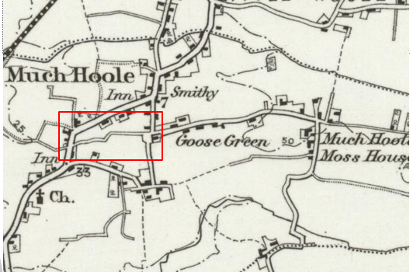
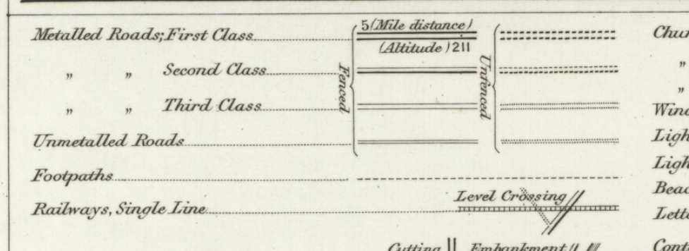
Observations |  | The scale of this map means that it is not possible to see the same amount of detail as is available on the 25 inch OS map detailed above although both maps were likely to have been published from the same survey.  A fenced route is shown consistent with how third class or unmetalled roads are shown.
Investigating Officer's Comments |  | The original scale of the map (1 inch to the mile) means that only the more significant routes are generally shown. The purpose of the map in the late 1800s would probably have been to assist the travelling public on horseback or vehicle suggesting that the through roads shown – and in this case the application route – most probably via the 'Historical route' D-E – was available for those travellers.
25 inch OS Map  Sheet LXVIII.15 | 1911 | Further edition of the 25 inch map surveyed in 1892, revised in 1909 and published in 1911.

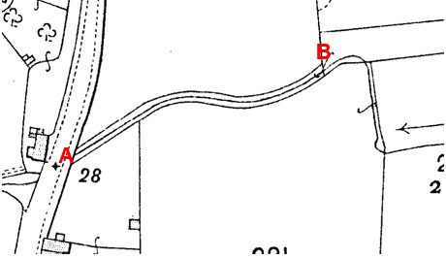
Observations |  | By 1909 there are several significant changes to the route. The route remains unaltered between point A and point B – fenced with the watercourse within it. A line is shown across the route at points A and B and at point B the land crossed by the application route is again shown braced with the parcel of land numbered 225a – along which the application route runs. West of point D a further line is shown across the route forming the eastern boundary of parcel 225a.  From point D the historical fenced route which ran along the eastern side of parcel 226 is no longer shown; the western boundary of the route has been removed and the historical route 'absorbed' into parcel 226 as indicated by overlaying the two maps and by reference to the acreage for plot 226 increasing from 1.505 in 1893 to 1.562 on this map.  The application route (FP30) is not shown between point D and point E along the fence bounding plot 226 and the historical route is not shown as a physical track on the ground.  A line is shown across the application route at point F and the footpaths shown to connect to the application route have altered slightly from the earlier edition of the OS 25 inch map and are now shown to meet the application route at point G.  From point F through to Smithy Lane the application route is shown as part of parcel 232.
Investigating Officer's Comments |  | It appears that the Historical route between D and F had been incorporated into the parcel 226 and may not have been passable to any traffic. The application route between those points is not shown and no inference can be made. The remainder of the route is unchanged from previous maps.
Bartholomew half inch Mapping | 1904-1941 | The publication of Bartholomew's half inch maps for England and Wales began in 1897 and continued with periodic revisions until 1975. The maps were very popular with the public and sold in their millions, due largely to their accurate road classification and the use of layer colouring to depict contours. The maps were produced primarily for the purpose of driving and cycling and the firm was in competition with the Ordnance Survey, from whose maps Bartholomew's were reduced. An unpublished Ordnance Survey report dated 1914 acknowledged that the road classification on the OS small scale map was inferior to Bartholomew at that time for the use of motorists.
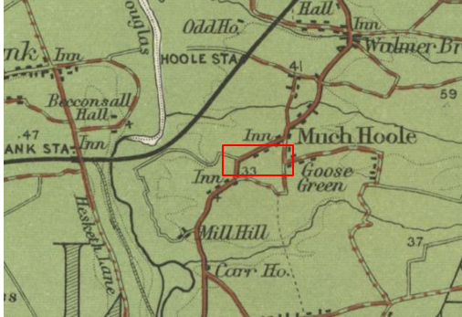

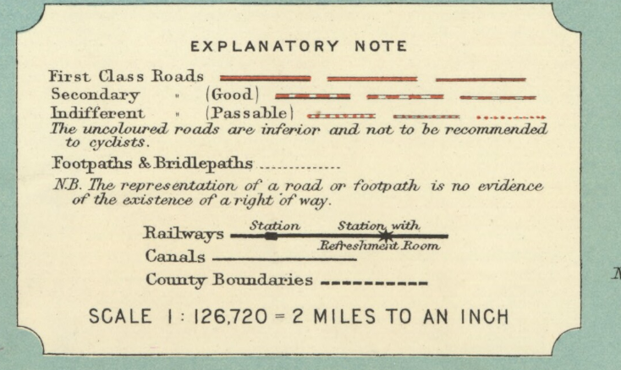
Sheet 8 – Liverpool & Manchester published 1904
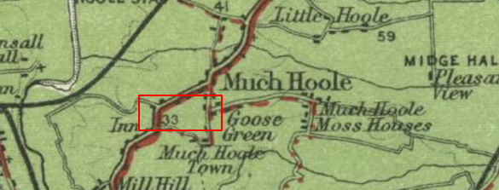

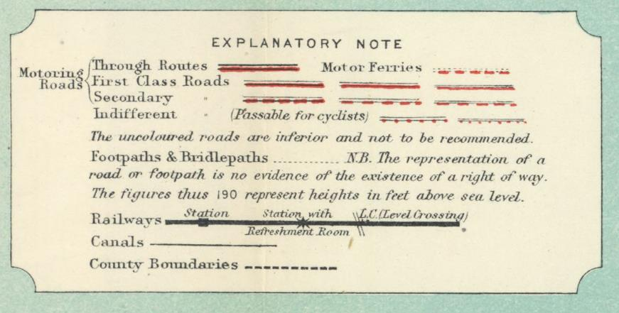
Sheet 8 – Liverpool and Manchester published 1920
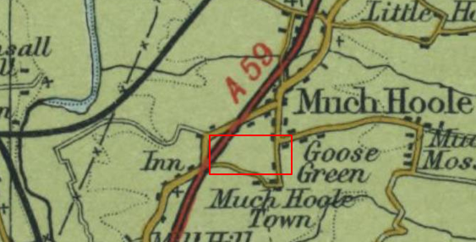

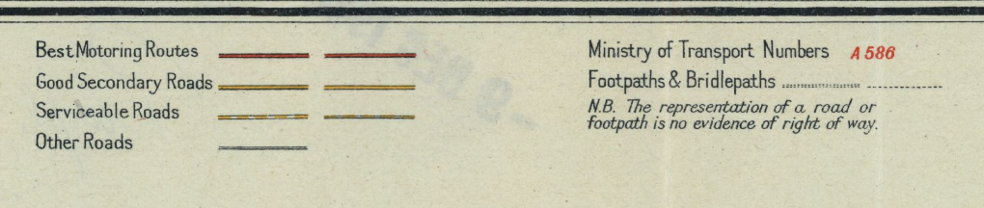
Sheet 31 – North Lancashire published 1941
Observations |  | The application route (including the Historical route D-E) is not shown on any of the three editions of the small-scale Bartholomew maps published between 1904 and 1941.
Investigating Officer's Comments |  | As Bartholomew's Maps were derived from the Ordnance Survey maps of that time it may be that the route had been purposely omitted by Bartholomew suggesting that if a route did still exist it was not considered to be a significant route at that time and was not considered to be a usable public vehicular road because footpath – and to some extent bridleway - users were not the target customers for these maps.
Finance Act 1910 Map  TNAs Ref IR 133/5/80 | 1910 | The comprehensive survey carried out for the Finance Act 1910, later repealed, was for the purposes of land valuation not recording public rights of way but can often provide very good evidence. Making a false claim for a deduction was an offence although a deduction did not have to be claimed so although there was a financial incentive a public right of way did not have to be admitted.  Maps, valuation books and field books produced under the requirements of the 1910 Finance Act have been examined. The Act required all land in private ownership to be recorded so that it could be valued and the owner taxed on any incremental value if the land was subsequently sold. The maps show land divided into parcels on which tax was levied and accompanying valuation books provide details of the value of each parcel of land, along with the name of the owner and tenant (where applicable).  An owner of land could claim a reduction in tax if his land was crossed by a public right of way and this can be found in the relevant valuation book. However, the exact route of the right of way was not recorded in the book or on the accompanying map. Where only one path was shown by the Ordnance Survey through the landholding, it is likely that the path shown is the one referred to, but we cannot be certain. In the case where many paths are shown, it is not possible to know which path or paths the valuation book entry refers to. It should also be noted that if no reduction was claimed this does not necessarily mean that no right of way existed.
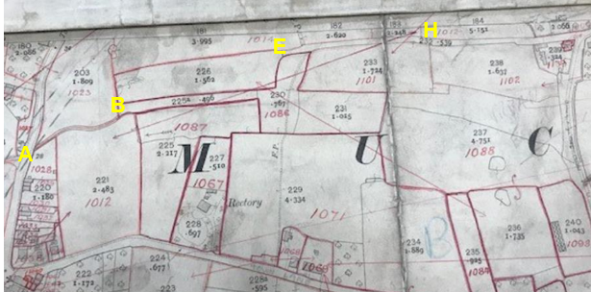
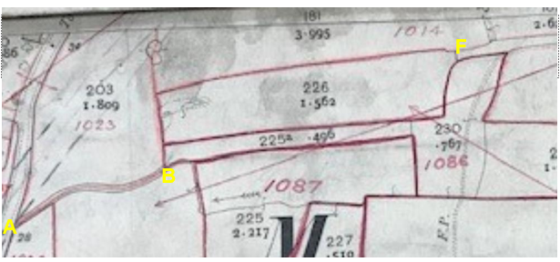
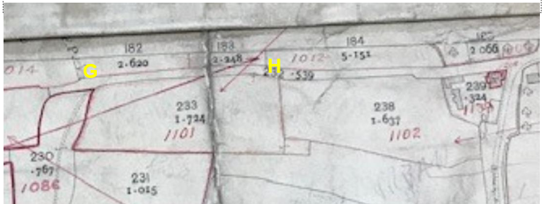
Extracts of Map deposited in the County Records Office
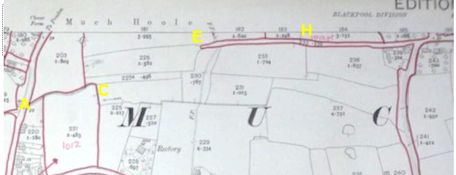
Map deposited in The National Archives
Observations |  | The map deposited in the County Records Office was difficult to read.  It appeared to show the route between point A and point B partly within hereditament 1023 From point B to point D the application route is within plot 1086 and the 'Historical route' D-E appears to be part of a split hereditament numbered 1089. There were no deductions for public rights of way or user recorded in the District Valuation book for the hereditaments listed above.  From point E to point H and through to Smithy Lane the drawing of the lines bounding the hereditaments appears incomplete but the numbering is done in such a way to suggest that the application route may not have been included. The map deposited in the National Archives was largely incomplete. Between point A and point C the application route is shown as part of hereditament 1012 and between point E and point H through to Smithy Lane the application route is shown excluded.
Investigating Officer's Comments |  | There are some inconsistencies between the two sets of records and neither map appears complete.  The records held by the county records office suggest that the landowners did not acknowledge the existence of any public rights along the route from point A to point E when the records were compiled and is unclear with regards to how the route from point E through to point H was to be shown  The map deposited in the National archives shows the route from point E to point H as being excluded suggesting that this part of the route may have been considered as a public vehicular highway that should be exempted from the valuation process but the map is incomplete and the information included on it differs from the County Records office map and the rest of the route is not excluded so no clear inference can be drawn.
25 Inch OS Map  LXVIII.15 | 1931 | Further edition of 25 inch map (surveyed 1892, revised in 1929 and published in 1931.
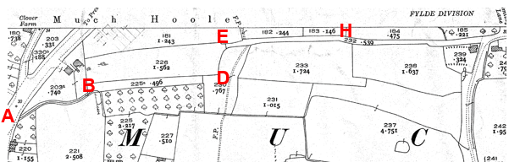
Observations |  | The land crossed by the application route (and Historical route D-E) remained unaltered from the earlier (1911) edition of the 25 inch map.
Investigating Officer's Comments |  | It appears that access along the full length of the application route (and Historical route D-E) may not have been possible – at least on horseback in the 1930s.
Authentic Map Directory of South Lancashire by Geographia | Circa1934 | An independently produced A-Z atlas of Central and South Lancashire published to meet the demand for such a large-scale, detailed street map in the area. The Atlas consisted of a large-scale coloured street plan of South Lancashire and included a complete index to streets which includes every 'thoroughfare' named on the map.  The introduction to the atlas states that the publishers gratefully acknowledge the assistance of the various municipal and district surveyors who helped incorporate all new street and trunk roads. The scale selected had enabled them to name 'all but the small, less-important thoroughfares'.
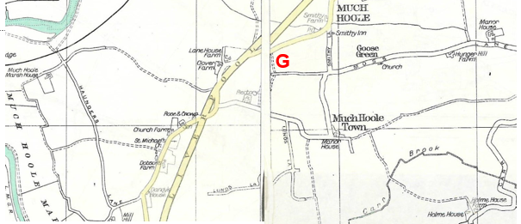
Observations significant route at that time. |  | The application route between point A and point G is not shown. From point G through to the junction with Smithy Lane (passing through point H) an unnamed route is shown which looks to continue just past point G west to the edge of the page.
Investigating Officer's Comments |  | The route between point A and point G is not shown suggesting that it was not a significant route at that time. The route from point G through to Smithy Lane existed in the 1930s and is shown in the atlas consistent with how other nearby routes of various statuses are shown. No inference can be made regarding the nature of use (i.e. whether it was on foot, horseback or vehicle) at that time.
Aerial Photograph | 1940s | The earliest set of aerial photographs available was taken just after the Second World War in the 1940s and can be viewed on GIS. The clarity is generally very variable.
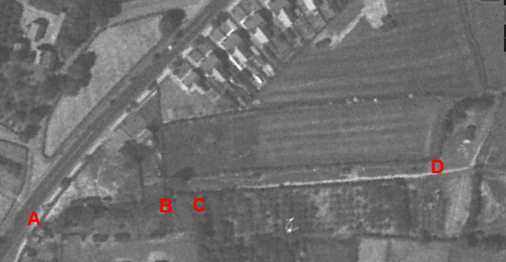
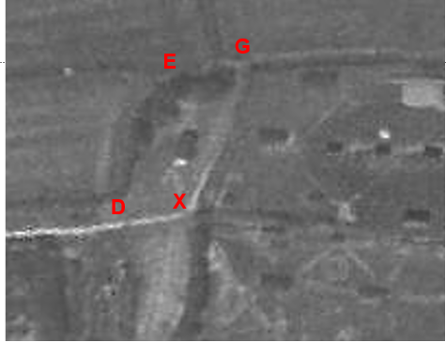
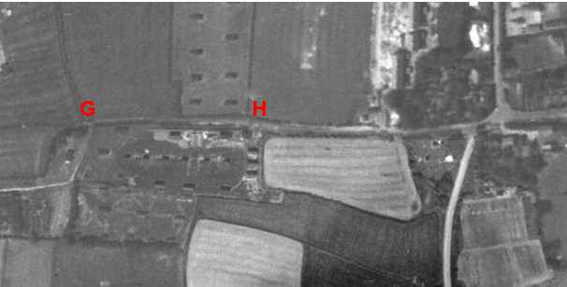
Observations |  | The application route is not visible as a worn track between points A-B-C. East of point C a worn track can be seen consistent with the application route which looks like it gives access to a plantation immediately south of the route. The visible track appears to be consistent with low levels of vehicular use – most probably farm machinery – and continues through point D to point X and then north east to point G.  The application route from point D to point E (along the field boundary) is not visible. A faint line can be seen from point D along the west side of the field boundary – consistent with the Historical route D-E.  From point E-G-H and continuing through to the junction with Smithy Lane the application route is visible.
Investigating Officer's Comments |  | It is not possible to determine from the aerial photograph whether the full length of the route was passable in the 1940s.  The surface is not visible along the full length suggesting that use of much of its use by the 1940s may have greatly diminished or ceased except for use by farm vehicles between point C and point D and along the section from point E though to point G and onwards to Smithy Lane.  The photograph provides no evidence of use of the application route between point D and point E.
6 Inch OS Map  Sheet 42SE | 1955 | The OS base map for the Definitive Map, First Review, was published in 1955 at a scale of 6 inches to 1 mile (1:10,560). This map was revised before 1930 and is probably based on the same survey as the 1930s 25-inch map.
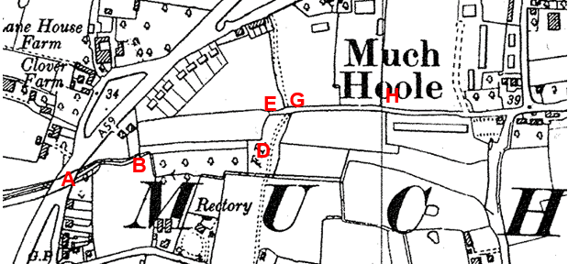
Observations |  | The application route is shown in the same way as it was depicted on the 1931 25 inch OS map from which this map derived.
Investigating Officer's Comments |  | It appears that access along the full length of the application route (and Historical route D-E) may not have been possible – at least on horseback in the 1930s.
1 inch OS  Sheet 94 - Preston | 1961 | One-inch to the mile, 7th Series OS map published 1961.
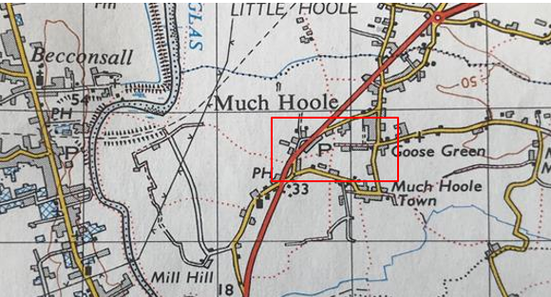
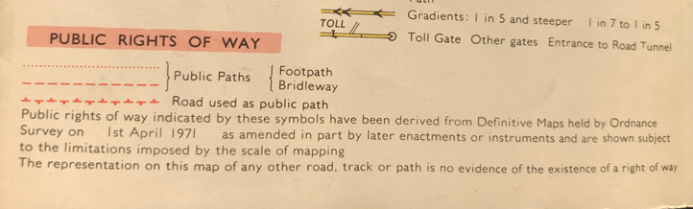
Observations |  | The land crossed by the application route is not shown in detail due to the scale of the map. A series of red dots consistent with the location of the route indicate the existence of the route which, by the 1960s, had been recorded on the Definitive Map and Statement as a public footpath. The key to the map explains that routes denoted by red dots were Public Paths – in this case footpaths with the information provided having been derived from Definitive Maps.
Investigating Officer's Comments |  | No inference can be drawn with regards to whether the route was accessible on the ground or what higher (than footpath) public rights may have existed at that time.
1:2500 OS Map  SD 4622-4722 | 1964 | Further edition of 25 inch map reconstituted from former county series and revised in 1962 and published 1964 as national grid series.
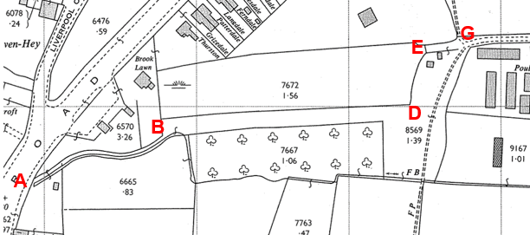
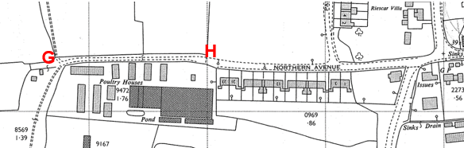
Observations |  | A fenced off strip containing the watercourse is shown between point A and point B and access appears unrestricted at point B continuing through to point D. FP 27 (and FP 28) is shown as a double dashed line annotated as footpath (F.P) indicating that a trodden track consistent with pedestrian use was visible on the ground. No such markings are present to indicate the application route from point A through to point D. Between point D and point E nether the application route (along the boundary) or Historical route (west of the boundary) are shown and a line is shown across the application route just east of point E. From point E-H-G the route is shown as part of a longer access road and east of point G the route is now named on the map as Northern Avenue.
Investigating Officer's Comments |  | It appears that access along the full length of the application may have been possible depending on whether access was available through the fence line at E but no 'trodden' route was shown on the map between point A and point E suggesting that any use of the route was quite low in numbers along this section.
Aerial photograph | 1960s | The black and white aerial photograph taken in the 1960s and available to view on GIS.
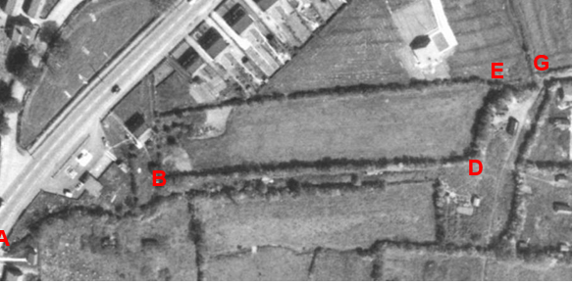
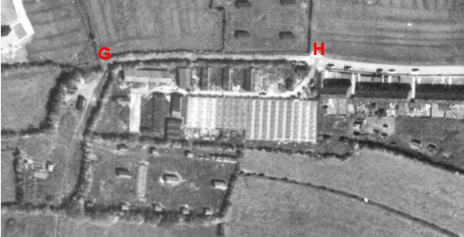
Observations |  | The 1960s aerial photograph is useful in relation to considering what was shown on the OS map published at that time. The route is not visible between point A and point B although the line it takes can be identified by the hedge-line. Between point B and point D a strip of land is visible which appears to be accessible and traces of a trodden track can be seen along it which increases in clarity as you approach point D – possibly indicating some vehicular use to access adjacent fields. From point D a track can be seen consistent with the application route on the east side of the fence-line but it looks like the route taken then veered off the application route to point G. From point G to point H the application route can be clearly seen. The historical route between point D and point E does not appear to exist.
Investigating Officer's Comments |  | No inference can be made with regards to the existence of public rights but the aerial photograph suggests that a route may have existed in the 1960s consistent with the fact that it was recorded as a public footpath at that time but that it received little use between point A and point D Beyond point G the route showed up on the photograph consistent with the fact that it appeared to be used as access to the adjacent poultry farm and fields.
1:2500 OS Map  SD 4622-4722 | 1978 | Further edition of 25 inch map reconstituted from former county series and revised in 1977 and published 1978 as national grid series.
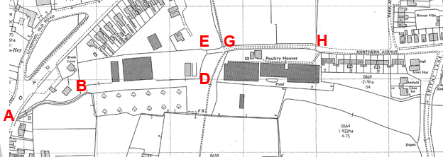
Observations |  | The land crossed by the application route appears not to have altered from the earlier edition of the OS map published in the 1960s.
Investigating Officer's Comments |  | It appears that access along the full length of the application may have been possible depending on whether access was available through the fence line at E but no 'trodden' route was shown on the map between point A and point E suggesting that any use of the route was quite low in numbers along this section.
Google Earth Pro | 2007-2009 | Aerial photographs available to view on Google Earth Pro.
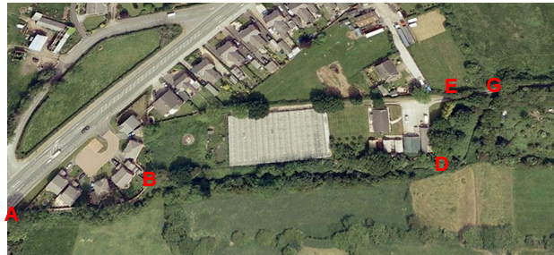
2007
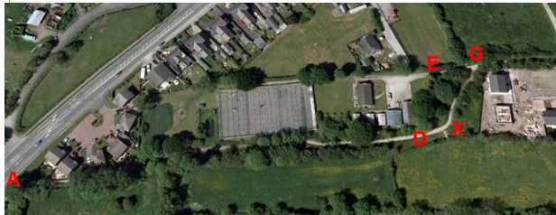
2009
Observations |  | The images obtained from Google Earth show that in 2007 a route consistent with pedestrian use was visible between point B and point D and a slightly more prominent line visible between points D-X-G.  In 2009 a very prominent route is shown indicating that the route had been surfaced – consistent with the modern day site evidence of a stone surfaced pathway (now partially overgrown). The surfacing work appears to have been carried out recently and the line of the path is consistent with the trodden track which was visible in 2007 between points D-X-G.
Investigating Officer's Comments |  | No inference can be made with regards to the existence of public rights but the aerial photograph suggests that a route may have existed in 2007 which was consistent with the fact that it was recorded as a public footpath at that time but that the trodden route from point D carried was to point X and point G rather than along either the application route or historical route.  The photograph taken in 2009 shows that work had been carried out to surface the route consistent with how a route recorded as a footpath would be surfaced. Of note was the fact that the surfacing followed the trodden track which was visible on the ground in 2007 from point D through point X to point G rather than the application route (definitive footpath) or historical route – suggesting that neither was in use as part of the pedestrian route in 2009.
Definitive Map Records |  | The National Parks and Access to the Countryside Act 1949 required the County Council to prepare a Definitive Map and Statement of Public Rights of Way.  Records were searched in the Lancashire Records Office to find any correspondence concerning the preparation of the Definitive Map in the early 1950s.
Parish Survey Map | 1950-1952 | The initial survey of public rights of way was carried out by the parish council in those areas formerly comprising a rural district council area and by an urban district or municipal borough council in their respective areas. Following completion of the survey the maps and schedules were submitted to the County Council. In the case of municipal boroughs and urban districts the map and schedule produced, was used, without alteration, as the Draft Map and Statement. In the case of parish council survey maps, the information contained therein was reproduced by the County Council on maps covering the whole of a rural district council area. Survey cards, often containing considerable detail exist for most parishes but not for unparished areas.
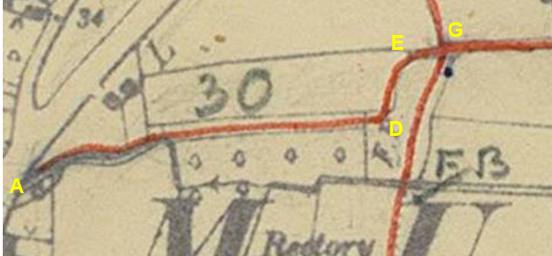
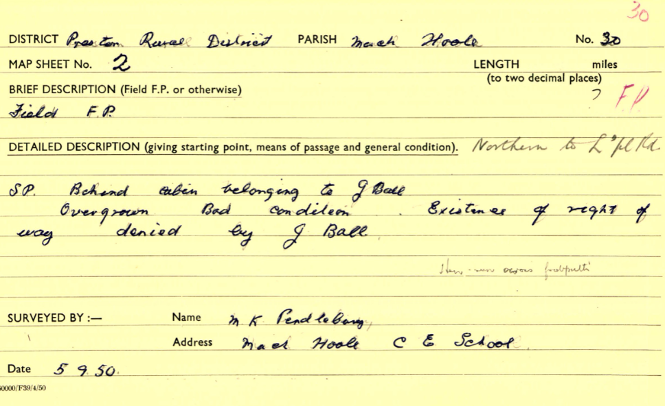
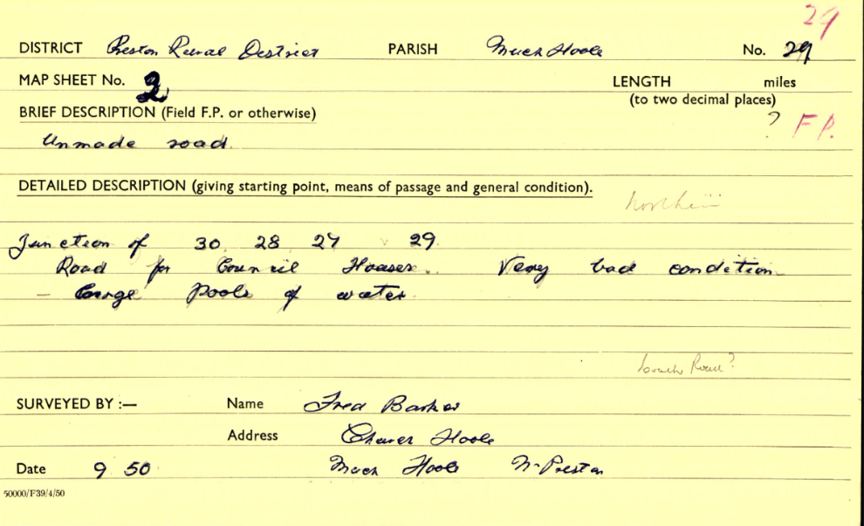
Observations |  | The application route was recorded as a public footpath on the Parish Survey Map. Between point A and point B the line drawn appears to run to the north of the enclosed route containing the watercourse and between point D and point E the line drawn on the map corresponds more to the Historical route (west of the fence/hedge). The parish survey card for FP 30 describes the route as a footpath which was overgrown, little used and disputed by J Ball.  From point G through to Smithy Lane the application route is included as part of FP 29 described as an unmade road providing access to council houses and was in bad condition. It was recorded as a footpath.
Draft Map |  | The parish survey map and cards for Much Hoole were handed to Lancashire County Council who then considered the information and prepared the Draft Map and Statement.  The Draft Maps were given a “relevant date” (1st January 1953) and notice was published that the draft map for Lancashire had been prepared. The draft map was placed on deposit for a minimum period of 4 months on 1st January 1955 for the public, including landowners, to inspect them and report any omissions or other mistakes. Hearings were held into these objections, and recommendations made to accept or reject them on the evidence presented.
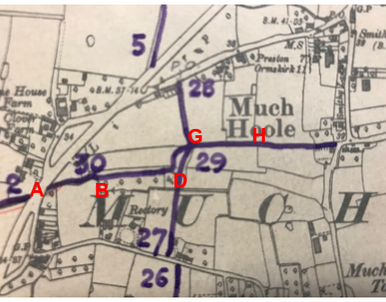
Observations |  | The application route was recorded as Footpath 30 and part of Footpath 29 on the Draft Map. A thick purple pen was used to draw the route on a small scale (6 inch to 1 mile map). The route of Footpath 30 between point A and point B was shown along the bounded route which contained the watercourse. The route from point D through to point G was shown along the field boundary.  No representations were made to the County Council about how either numbered footpath was shown.
Provisional Map |  | Once all representations relating to the publication of the draft map were resolved, the amended Draft Map became the Provisional Map which was published in 1960, and was available for 28 days for inspection. At this stage, only landowners, lessees and tenants could apply for amendments to the map, but the public could not. Objections by this stage had to be made to the Crown Court.
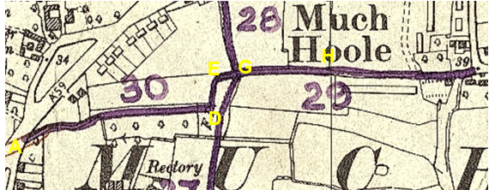
Observations |  | The application route was recorded as a public footpath on the Provisional Map. Again, the use of a thick purple pen makes it difficult to determine the alignment of the route between point D and point E.  There were no representations made regarding how the application route was recorded.
The First Definitive Map and Statement |  | The Provisional Map, as amended, was published as the Definitive Map in 1962.
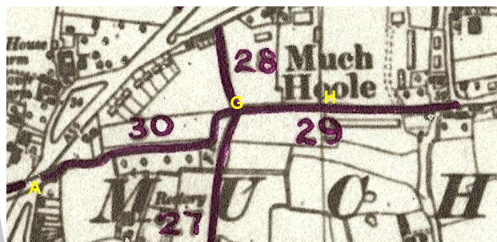
Observations |  | The application route was recorded as a public footpath. The scale of the map and thick purple pen used to prepare the hand drawn map means that it is not possible to be certain which side of the fence line the route was recorded to go between point D and point E.
Revised Definitive Map of Public Rights of Way (First Review) |  | Legislation required that the Definitive Map be reviewed, and legal changes such as diversion orders, extinguishment orders and creation orders be incorporated into a Definitive Map First Review. On 25th April 1975 (except in small areas of the County) the Revised Definitive Map of Public Rights of Way (First Review) was published with a relevant date of 1st September 1966. No further reviews of the Definitive Map have been carried out. However, since the coming into operation of the Wildlife and Countryside Act 1981, the Definitive Map has been subject to a continuous review process.
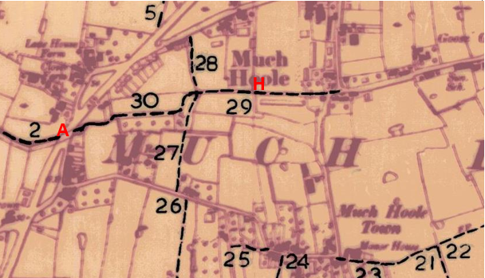
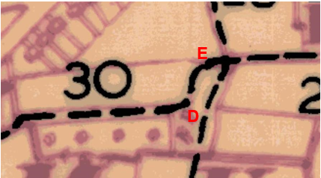
Observations |  | The application route is recorded as a public footpath. Between point D and point E the Investigating Officer considers that the hand drawn line denoting the route of the footpath is astride the fence line (the digitised map of public rights of way shows it to the east – it is not known why).  At the time that the Definitive Map and Statement of Public Rights of Way was prepared, that part of the route of FP 29 now recorded as a public vehicular highway named as Northern Avenue had not been adopted by the County Council – hence it's inclusion on the Definitive Map.
Investigating Officer's Comments |  | From 1953 through to 1975 there is no indication that the application route was considered to be anything other than a public footpath. There were no objections or representations made with regard to what was shown when the maps were placed on deposit for inspection or at any stage of the preparation of the Definitive Map.  At each stage of the Definitive Map process section D-E is shown on the field boundary with no clear indication whether the intention was to show it on the west or east.
Highway Adoption Records including maps derived from the '1929 Handover Maps' | 1929 to present day | In 1929 the responsibility for district highways passed from district and borough councils to the County Council. For the purposes of the transfer, public highway 'handover' maps were drawn up to identify all of the public highways within the county. These were based on existing Ordnance Survey maps and edited to mark those routes that were public. However, they suffered from several flaws – most particularly, if a right of way was not surfaced it was often not recorded.  A right of way marked on the map is good evidence but many public highways that existed both before and after the handover are not marked. In addition, the handover maps did not have the benefit of any sort of public consultation or scrutiny which may have picked up mistakes or omissions.  The County Council is now required to maintain, under section 31 of the Highways Act 1980, an up to date List of Streets showing which 'streets' are maintained at the public's expense. Whether a road is maintainable at public expense or not does not determine whether it is a highway or not.
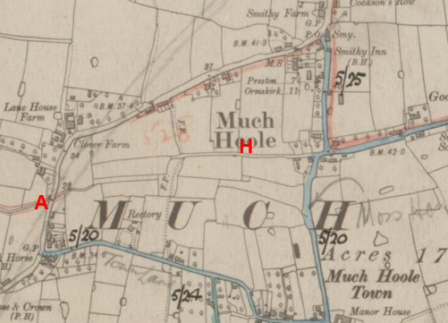
Handover Map
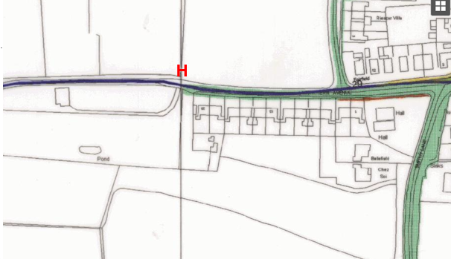
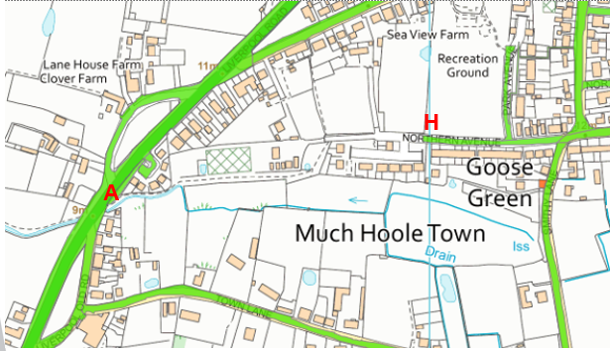
Observations |  | The first 20 metres of the application route, west of point A, now crosses land that is part of the publicly maintainable Liverpool Road. From A to point H the application route is not recorded as a publicly maintainable highway on the county council's highway records.
Investigating Officer's Comments |  | The fact that the route is not recorded as a publicly maintainable highway does not mean that it does not carry public rights of access so no inference can be drawn.
Highway Stopping Up Orders | 1835 - 2014 | Details of diversion and stopping up orders made by the Justices of the Peace and later by the Magistrates Court are held at the County Records Office from 1835 through to the 1960s. Further records held at the County Records Office contain highway orders made by Districts and the County Council since that date.
Observations |  | No legal orders relating to the creation, diversion or extinguishment of public rights have been found.
Investigating Officer's Comments |  | If public rights are found to exist along the application route they do not appear to have been subsequently diverted or extinguished by a legal order.
Statutory deposit and declaration made under section 31(6) Highways Act 1980 |  | The owner of land may at any time deposit with the County Council a map and statement indicating what (if any) ways over the land he admits to having been dedicated as highways. A statutory declaration may then be made by that landowner or by his successors in title within ten years from the date of the deposit (or within ten years from the date on which any previous declaration was last lodged) affording protection to a landowner against a claim being made for a public right of way on the basis of future use (always provided that there is no other evidence of an intention to dedicate a public right of way).  Depositing a map, statement and declaration does not take away any rights which have already been established through past use. However, depositing the documents will immediately fix a point at which any unacknowledged rights are brought into question. The onus will then be on anyone claiming that a right of way exists to demonstrate that it has already been established. Under deemed statutory dedication the 20 year period would thus be counted back from the date of the declaration (or from any earlier act that effectively brought the status of the route into question).
Observations |  | No Highways Act 1980 Section 31(6) deposits have been lodged with the county council for the area over which the application route runs.
Investigating Officer's Comments |  | There is no indication by the landowners under this provision of non-intention to dedicate public rights of way over this land.

The affected land is not designated as access land under the Countryside and Rights of Way Act 2000 and is not registered common land.

The Natural Environment and Rural Communities Act 2006

This Act effected a blanket extinguishment of unrecorded public rights for mechanically propelled vehicles (MPVs) with certain exceptions. Prior to this carriageway rights did not discriminate between vehicles which were mechanically propelled, such as cars and motorbikes, and those which were not, such as bicycles, wheelbarrows, horse-drawn carriages, donkey carts, etc. If Committee concludes that the evidence shows that, on the balance of probability, public carriageway rights subsist or it is reasonably alleged that they subsist, along the application route via the Historical route D-E it is then necessary to consider whether the Natural Environment and Rural Communities Act 2006 has extinguished public rights for MPVs. The application route was, at the time of the Act was recorded as a public footpath with the exception of the Historical route D-E which was not recorded and neither the application or Historical route were on the List of Streets (maintained at public expenses) and we have no evidence that either was used mainly by the public with MPVs at that time. There is no claim that any other of the other exemptions apply. Therefore, in the event that public carriageway rights are shown to exist the appropriate status to be recorded on the Definitive Map and Statement would be Restricted Byway, with public rights for non-mechanically propelled vehicles, horses or on foot.

Summary

This investigation has been carried out based entirely on historical map and documentary evidence with no modern user evidence submitted.

As with most cases investigated, there is no single piece of map or documentary evidence which stands alone to confirm the public legal status of the route.

In this particular case the application was for the route recorded as Footpath 30 and part of Footpath 29 to be upgraded to bridleway.

It is finely balanced but there appears to have been a public carriageway established by the mid-19th Century as evidenced by the Tithe Award and supported by Hennet and the Ordnance Survey maps (First Edition 6" and 1" Cassini reproduction). Over the next 100 years the use and availability of the route reduced - the stream encroaching between A-B, which may or may not have prevented use of part of the width, the Historical route between D-E being incorporated into the field which means that it may or may not have been available, and gates (or possibly fences) being erected at points along the route. Modern use is only possible on foot and more recently the infrastructure has been improved but the used route between D-G is not on either the Historical route or the application route.

The First Edition 25 inch map – surveyed in 1892 – provides the most precise detail from which it can be seen that the route depicted on the early mapping detailed above (as a bounded route) varied from the application route between point D and point E, the historical route lying to the west of the boundary and the Definitive Map route being on the boundary.

By the early 1900s – as evidenced by the Second Edition 25 inch OS map – the bounded track between point D and point E no longer existed and a number of fences appear to have been erected across the route suggesting that it may no longer have been accessible along the full length to vehicles or on horseback. The Finance Act 1910 evidence is incomplete and inconsistent and only supports E-H being carriageway or bridleway.

Map and documentary evidence from the early 1900s onwards is not strong in support of the assertion that the route applied for was or could be used by the public as a bridleway and there is no modern user evidence in support of the application supporting the dedication of bridleway rights.

We therefore conclude that the carriageway rights were established by mid-19th Century and subsequent falling out of use has not removed these. However the effects of the Natural Environment and Rural Communities Act 2006 is to extinguish public rights for mechanically propelled vehicles. The correct status would therefore be restricted byway following the Historical route not the application route between D-E. There is no evidence for supporting higher rights on the application route between D-E.

Head of Service – Legal and Democratic Services Observations

Landownership

From its western end to point B the application route crosses land owned by Jones Homes (Lancashire) Limited. From point B to point E the route crosses land owned by Isherwood Developments Limited. From point E to point H the route crosses land where there is a caution registered under title LAN139664 but the ownership remains unknown. Notices have been posted and no owner has come forward.

If a decision is made to make an Order to record a highway along the historical line the owners of that section will be informed and should they have any relevant information causing officers concern that the decision is flawed the information will be brought to the attention of the committee before an Order is made. They are already aware of the application.

Information from the Applicant

The applicant submitted the following map and documentary evidence in support of their application:

Hennet's Map of Lancashire 1829
6 inch OS map published 1848
1 inch OS map published 1896
25 inch OS map published in 1893, 1911 and 1931
1 inch OS map published 1961
Finance Act Map 1910
Tithe Map and Award 1841
Modern digital mapping showing the recorded route of 7-8-FP30 and 7-8-FP29
Photographs of the route taken April/May 2020

Information from Others

Atkins Global, Cadent Gas and Virgin Media responded to consultations stating they had no objections.

Information from the Landowners

One of the landowners responded to consultation to raise an objection, they questioned the line of the application route not following the existing route on the ground, noting that the line of the application route in part runs through an area of well established trees which block use of this line.

They went on to note that part of the application route is only 1.1 metres wide, being bounded by a high fence on one side and a steep descent to a brook on the other.

Assessment of the Evidence

The Law - See Annex 'A'

In Support of Making an Order(s)

Mapping evidence of a route in existence
Tithe Map evidence

Against Making an Order in respect of Pre-1890s vehicular route
Evidence is limited

Against Making an Order in respect of a dedication of vehicular or bridleway after 1890
Changes to the route.
Inconsistent Finance Act information.

Conclusion

Committee is asked to consider whether there is sufficient evidence from which to infer that a dedication must have happened many many decades ago for the route to be shown on various documents in the way that it was and consider what status the highway was .

Common Law inference is drawn from all the circumstances including documentary evidence.

From the report Committee can see that there is good but limited evidence of this being a pre-1890 vehicular highway which then lost width and boundaries, appears gated and began to be inconsistently recorded ending up recorded as a footpath apart for one short section where the footpath was recorded as being along a boundary instead of on the west side.

Unless stopped up by proper legal process a highway remains where it was dedicated even if no longer used. The rights still remain. The legal maxim is "Once a highway always a highway".

This is a finely balanced evaluation given the limited evidence pre-1890.

If Committee is content that there is sufficient evidence of an old vehicular highway between A and H the Natural Environment and Rural Communities Act 2006 will have extinguished modern mechanically propelled vehicular rights leaving the route to be appropriately recorded as a restricted byway.

If committee is content that there is sufficient evidence of an old pre-1890 vehicular highway A-H Committee is invited to consider that the line of that highway was along the historical line noted on the Committee Plan rather than the Definitive Map line of FP30 between points D-E.

It is suggested that on balance there is sufficient evidence for an Order to be made and promoted to confirmation in accordance with the recommendation.

Risk management

Consideration has been given to the risk management implications associated with this claim. The Committee is advised that the decision taken must be based solely on the evidence contained within the report, and on the guidance contained both in the report and within Annex 'A' included in the Agenda Papers. Provided any decision is taken strictly in accordance with the above then there is no significant risks associated with the decision making process.

Local Government (Access to Information) Act 1985

List of Background Papers

Paper | Date | Contact/Directorate/Tel
All documents on File Ref: 804-627 |  | Simon Moore, 01772 531280, County Secretary and Solicitors Group
Reason for inclusion in Part II, if appropriate

N/A

The Ordnance Survey (OS) has produced topographic maps at different scales (historically one inch to one mile, six inches to one mile and 1:2500 scale which is approximately 25 inches to one mile). Ordnance Survey mapping began in Lancashire in the late 1830s with the 6-inch maps being published in the 1840s. The large scale 25-inch maps which were first published in the 1890s provide good evidence of the position of routes at the time of survey and of the position of buildings and other structures. They generally do not provide evidence of the legal status of routes, and carry a disclaimer that the depiction of a path or track is no evidence of the existence of a public right of way.
Aerial photographs can show the existence of paths and tracks, especially across open areas, and changes to buildings and field boundaries for example. Sometimes it is not possible to enlarge the photos and retain their clarity, and there can also be problems with trees and shadows obscuring relevant features.

